Ollscoil na hÉireann, Corcaigh
National University of Ireland, Cork



FYP

Iteration 2
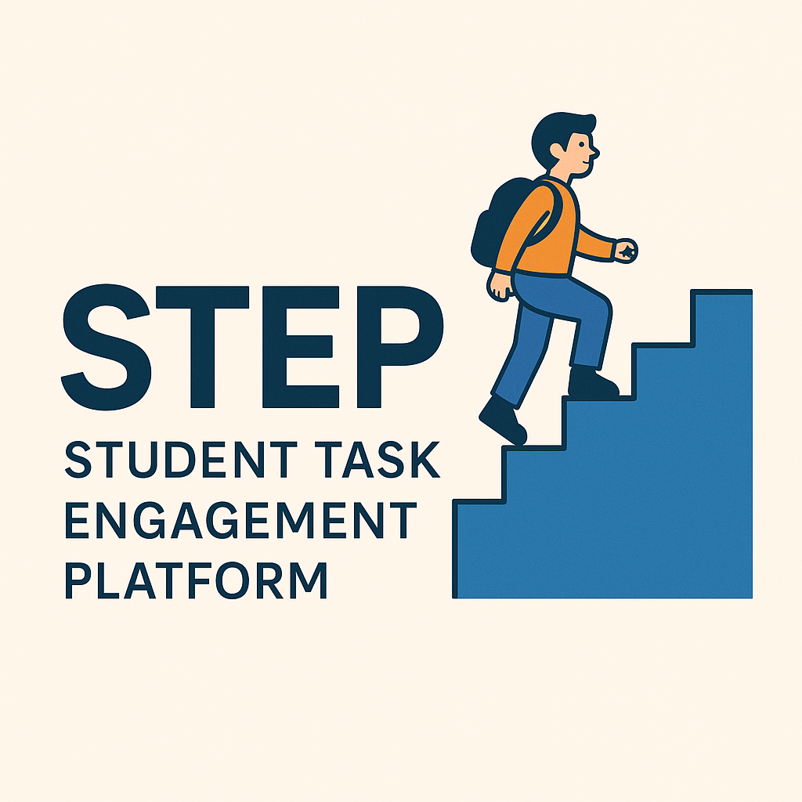

By
[Ben Murphy, 122438066]

[21/11/2025]

Table of Contents
1.Project Overview 3
1.2 What the platform provides 3
2.Major changes since proposal 4
3.Product Backlog list 5
Fig 3.1: Updated Product Backlog List 6
4. Iteration Review 7
4.1 A description of how the iteration on went. 7
4.2 The Development Process 8
Fig 4.3 Admins can create a profile 8
Fig 4.4 Code for admins creating a profile 9
Fig 4.5 Admins can view all student accounts registered on the platform 9
Fig 4.6 Code for admin viewing students 10
Fig 4.7 Admins can verify student accounts and manage disputes created by students or company’s 10
Fig 4.8 Code to verify students accounts 11
Fig 4.9 Code for students or companies creating disputes 12
Fig 4.10 Students can view available tasks on dashboard 13
Fig 4.11 Code showing students tasks on their dashboard 14
Fig.4.12 Students can filter tasks by skill and estimated time frame 15
Fig 4.13 Code showing students can filter tasks 15
5. Completed This Iteration 16
5.1 What Went Well 16
5.2 Difficulties & How They Were Handled 16
5.3 User / Stakeholder Interaction 16
6. Testing 20
6.1 Testing Student Registration and Login 20
6.5 Issues discovered and changes made: 20
6.7 Future Testing Improvements 22
7.Risks 23
8. Plan for Next Iteration 24
8.1 Company’s applicants and select a candidate 24
8.2 Company’s review submissions and request changes 24
9. Source Breakdown 25
10. References 26

1.Project Overview
A summary of what the project aims to achieve and the problem it solves.

This project aims to develop a digital marketplace platform that connects universities and their students with companies who need more capacity to clear their backlog of tasks.
Companies face resource bottlenecks at the end of sprint cycles, leaving tasks unfinished. At the same time, students struggle in the early years of their course to access meaningful, paid industry experience that builds their skills and resumes.
This system addresses both challenges by creating a trusted, structured environment where students can apply for, deliver and get paid for completing these published tasks.

1.2 What the platform provides
For Students: A verified account linked to their university email, where they can display academic performance, project experience, and lecturer endorsements. Students gain access to real, paid tasks, and can build a portfolio of completed work supported by ratings and feedback from industry. This helps bridge the gap between academic study and professional practice.

For Companies: A straightforward way to post tasks with clear milestones and acceptance criteria, supported by integrated contract e-signings (NDAs) and payouts. The rating and feedback system ensures accountability, transparency, and repeatability. This reduces risk while increasing efficiency.

For Universities: Giving their talented students the opportunity to become visible to companies. Visibility into how students engage with industry opportunities, the ability to confirm student profiles, and the option to report on skills developed that benefit both students and employers.

The system is built around transparency, and efficiency. Verification mechanisms, student email confirmation, business identity checks, secure digital contracts, encrypted data handling, and two-sided ratings all contribute to a safe and reliable marketplace.

2.Major changes since proposal
A brief outline of any significant changes to the system since the proposal stage.

No major scope changes currently. The core proposition, stakeholders, and feature set remain consistent: task/milestone marketplace, verification, e‑signing, milestone delivery, payments, and ratings.

3.Product Backlog list

Fig 3.1: Current Product Backlog List
Priority | AS A... | I WANT TO... | SO THAT... | STATUS | Planned FOR CURRENT ITERATION | PLANNED FOR NEXT ITERATION
1 | Student | Create a verified profile and sign up using my student email. | So that I can reach the student dashboard page | Completed  Iteration 1
2 | Company | Post scoped tasks with milestones & acceptance criteria | I can outsource sprint backlog tasks safely | Completed  Iteration 1
3 | Admin | Verify accounts and manage disputes | Platform integrity and fairness are supported | Completed in iteration 2 | Yes
4 | Student | Browse & filter tasks based on skill and timeframe | I can quickly find job opportunities that suit me | Completed in iteration 2 | Yes
5 | Company | Review applicants and select a candidate | I can ensure I choose the best fit for the task |  |  | Yes
6 | Company | Review submissions & request changes | I can enforce quality standards before making payment |  |  | Yes
7 | Company | Approve milestones and confirmation of payments released | I only pay for accepted and satisfactory work
8 | Student/Company | Rate and review each other | Trust and credibility improve over time
9 | Admin | Verify accounts and manage disputes | Platform integrity and fairness are supported
10 | University | Reference student accounts and view analytics | Students can have a university reference, while keeping track of student’s progress

4. Iteration Review

4.1 A description of how the iteration went.
Iteration 2 went well.
I found actively working on the new updated user stories in the product backlog list brought more clarity to the system and its processes and how will run. I am actively learning and constantly intaking information while creating this iteration.

4.2 The Development Process
This iteration focused on delivering users story’s 3+4 from the product backlog list

User story 3: Admins can verify Accounts and manage disputes

Fig 4.3 Admins can create a profile
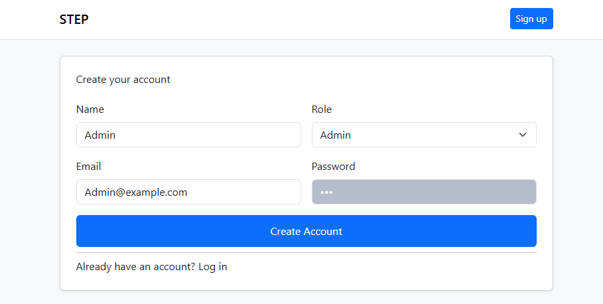 Figure 4.3 illustrates the new functionality introduced in Iteration 2 that allows administrators to create dedicated admin profiles within the platform. This enhancement supports the expansion of system governance features by distinguishing administrators from standard student and company accounts.

Fig 4.4 Code for admins creating a profile
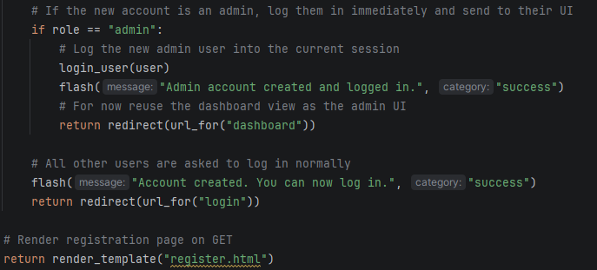

Fig 4.5 Admins can view all student accounts registered on the platform
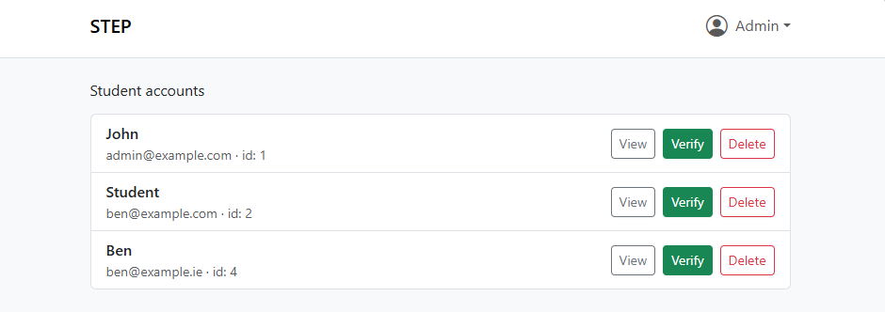
Figure 4.5 demonstrates the new administrative capability introduced in Iteration 2 that allows platform administrators to view all student accounts and has the option to view the accounts in detail, delete the account or add a verification badge to the account.

Fig 4.6 Code for admin viewing students 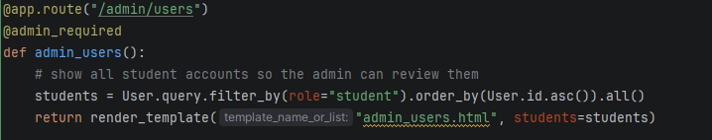

Fig 4.7 Admins can verify student accounts and manage disputes created by students or company’s
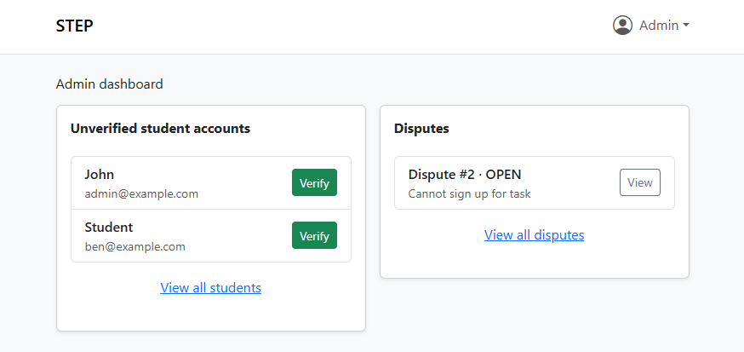
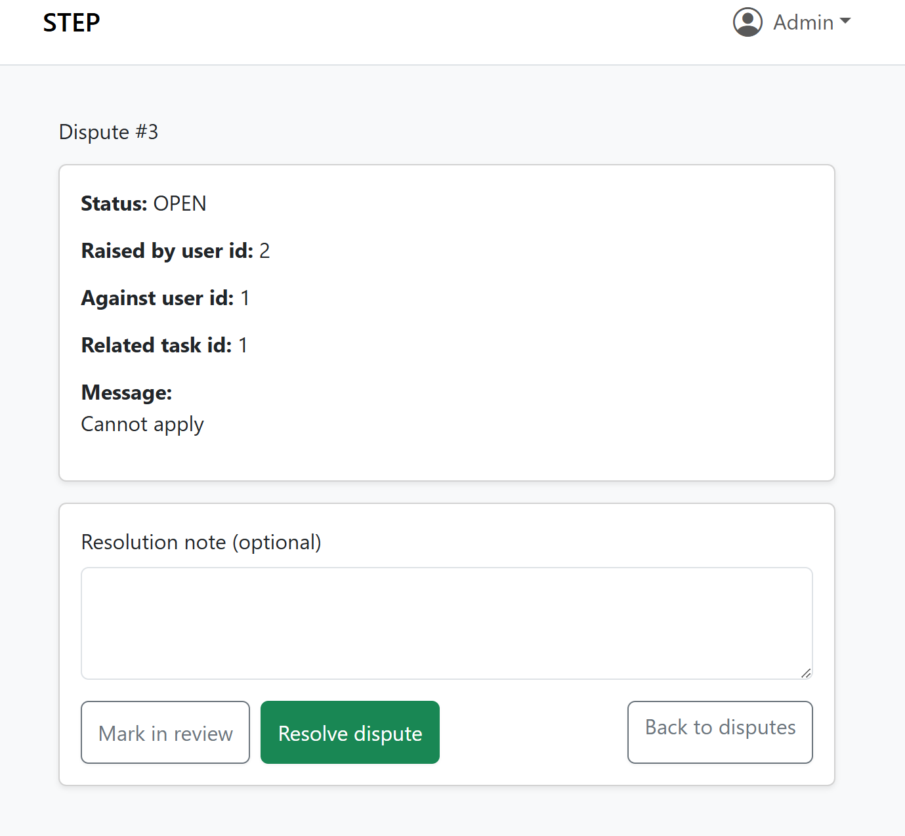
Figure 4.7 displays the admin verification feature added in Iteration 2. Admins can now use the “Verify” action on student profiles to confirm account authenticity before students interact with companies or apply for tasks. Admins can also manage any disputes raised by companies or students on the platform, they have the option to resolve the dispute with a solution or to mark it in review. This process boosts trust, ensures platform standards, and marks verified profiles with a visible badge.

Fig 4.8 Code to verify students accounts
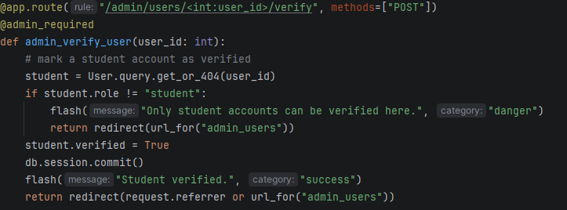
Fig 4.9 Code for students or companies creating disputes 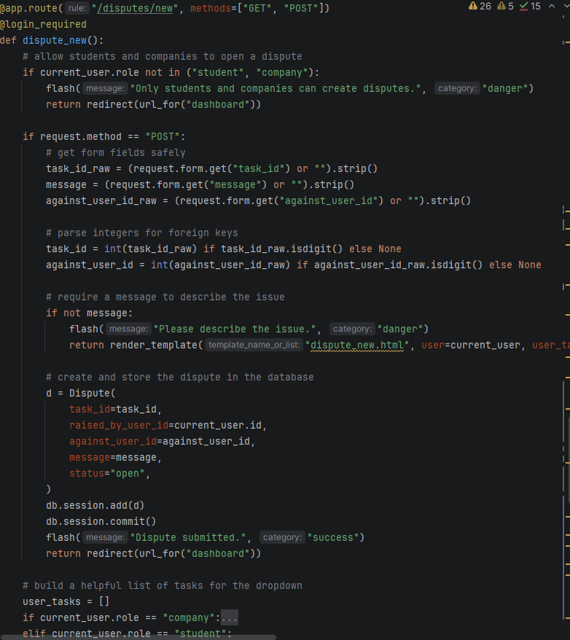

User story’s 4: Students can browse and filter tasks based on skills and timeframes

Fig 4.10 Students can view available tasks on dashboard
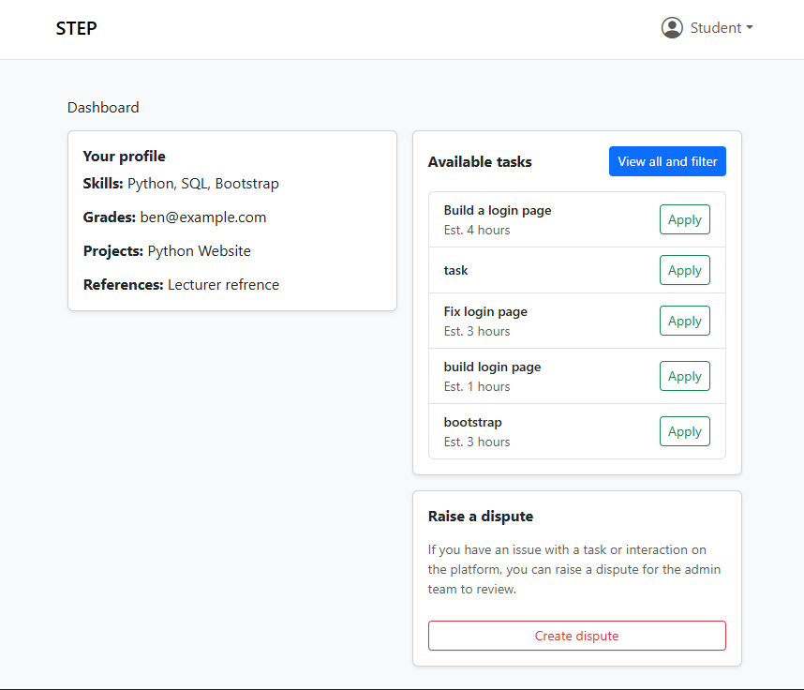
Students now have the option to view all available tasks on their dashboard. Students also have the option to create a dispute which will appear on the admin dashboard.

Fig 4.11 Code showing students tasks on their dashboard
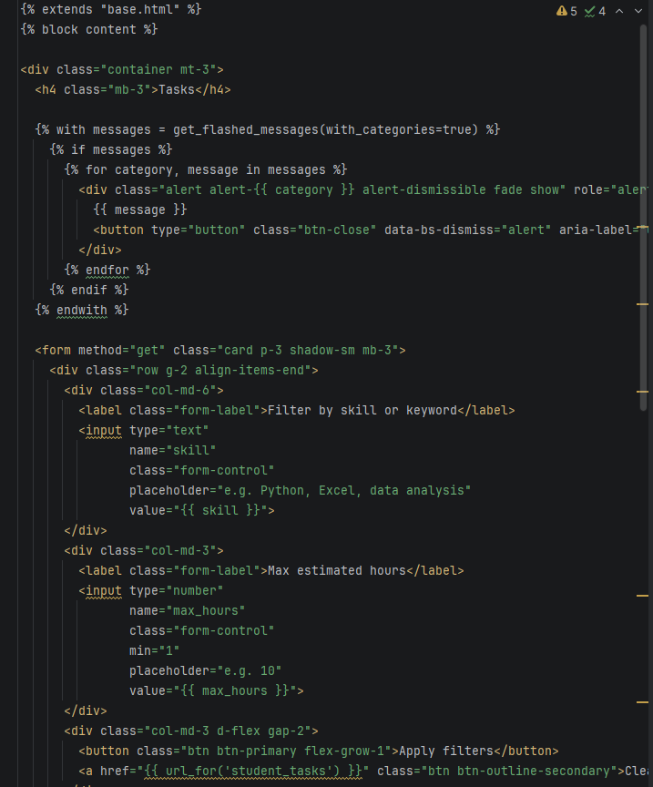

Fig.4.12 Students can filter tasks by skill and estimated time frame
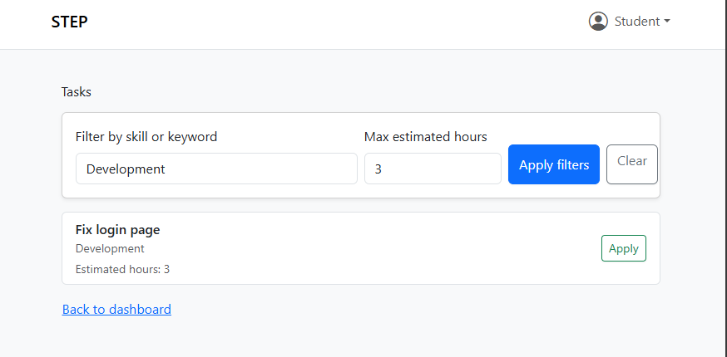

Fig 4.13 Code showing students can filter tasks
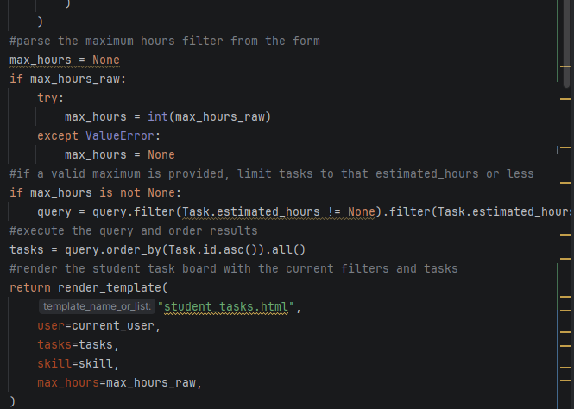

5. Completed This Iteration
Admins can sign up and create an account. Admin can view students’ profile and details and verify them or delete the account if needed. Admins can manage disputes raised by students or companies.
Students and companies can raise disputes which will appear on admin dashboard
Students can filter tasks based on skill and time

5.1 What Went Well
One of the biggest successes in iteration 2 was the introduction of administrator accounts. The system now supports three distinct roles, students, companies, admins each with customized privileges
The implementation of the admin verification on student profiles and the addition of admins being able to manage disputes adds a level of integrity and transparency to the platform and makes users feel safe.

5.2 Difficulties & How They Were Handled
Introducing the dispute reporting feature required adding a new model, new routes, and several templates. The main difficulty was ensuring these additions did not conflict with existing student routes or redirect logic. Several 404 and routing errors occurred during early testing. This was handled by carefully mapping URL paths and systematically testing each step of the dispute workflow until it behaved consistently.

5.3 User / Stakeholder Interaction
Tom Murphy
Data Analyst, Deloitte

Ben’s STEP platform offers a solid solution to the challenge of connecting students with short-term, skills-based opportunities. The prototype shows progress but needs clearer decision justification, better user alignment, and more supporting evidence.
To improve, I suggested Ben clarify the platform’s value, demonstrate its basis in real problems, and consistently align design choices with stakeholder needs.
- Alignment With End Users
I advised Ben to clearly document each end-user group’s needs:
- Students: easy discovery/filtering, proof of experience, transparency, low friction
- Companies: simple posting, clear skills, visibility of interest, applicant quality
- Admin: oversight, verification, integrity controls

6. Testing
Testing for this iteration focused on the two completed user stories:
- Admin registration and login
- Student task filtering

6.1 Testing Student Registration and Login
Tests conducted:
- User Role Authentication tests ensured students, companies and admins were directed to their correct dashboards.
- Disputes created would end up on admin dashboard to be resolved and removed from disputes.
- Admins actions evaluated = Mark as in review, resolve dispute, add resolution notes.
- Evaluated deletion of accounts via admin.

6.5 Issues discovered and changes made:

Multiple errors (TemplateNotFound) occurred when attempting to render admin dispute pages such as: admin_user_detail.html admin_dispute_detail.html dispute_new.html
Cause:
Templates were either not created, not saved, or named incorrectly.
Change Made:
All missing templates were added to the /templates directory with consistent naming and the correct Jinja inheritance ({% extends "base.html" %}). File references in routes were updated to match the filenames exactly.

Dispute System Not Appearing on Admin Dashboard
Issue:
Even though routes and templates existed, the admin dispute list never appeared.
Cause:
The admin dashboard template (admin_home.html) did not include a section to display disputes, and the view did not pass dispute data into the template.
Change Made:
- Updated route to pass open_disputes to the template.
- Added UI cards to display open disputes.
- Implemented links to detailed dispute views.

6.7 Future Testing Improvements
Introduce Usability and UX Testing
While functionality works, usability testing would ensure the interface is intuitive. Future improvements include:
- Testing with real users to evaluate navigation paths for admin, student, and company roles.
- Verifying whether buttons, filters, and dispute options are easy to find and understand.
- Identifying areas that require clearer instructions or improved layout.
This would help refine the user experience, especially on the student dashboard and admin console.

7.Risks
Filtering and browsing tasks may cause performance issues later
Currently all tasks are loaded at once. As more tasks are created, this could slow down the student dashboard.
Plan: introduce pagination and indexed search once basic browsing is working.

8. Plan for Next Iteration
The upcoming development cycle will concentrate on completing user story’s 5 and 6. These are essential steps to ensure the platform's core functionality and operational readiness. User story’s 5 + 6:

8.1 Company’s applicants and select a candidate
The next priority on the list is to give companies the ability to select from the applicants that have applied to their tasks posted. It also gives students the opportunity to be seen by companies. A core principle of this project.

8.2 Company’s review submissions and request changes
The following user story incorporates a review option for companies and the ability to give constructive feedback for students, which is extremely valuable, and I think to be a key feature in this project. It gives companies the ability to keep standards high and showing students what high standards look like.

9. Source Breakdown
- ChatGPT 40%

- Web/YouTube 20 %

- Own work 40%

10. References

Accessed on 18/11/2025
Bootstrap layout guide

Accessed on 18/11/2025
filter() in python - GeeksforGeeks

